HADOOP DOCUMENTATION
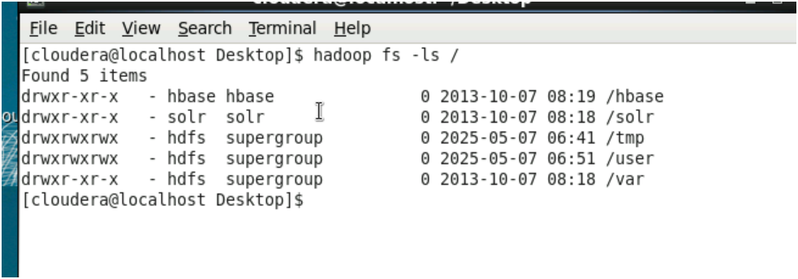
1.To list the contents of root folders

2.To list the contents of the directory user
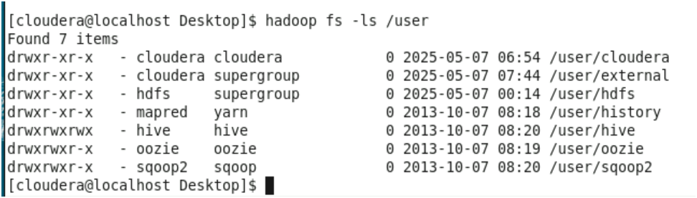

3.To create a folder on another folder and check whether it is created or not
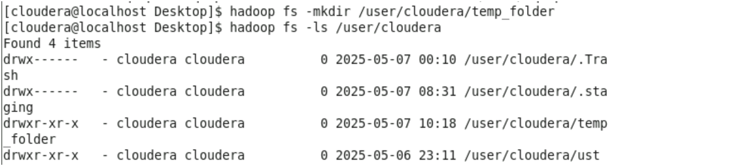

4.To copy and upload a file from its source location to another location and open the file from its new location
5.To check the health details of a file
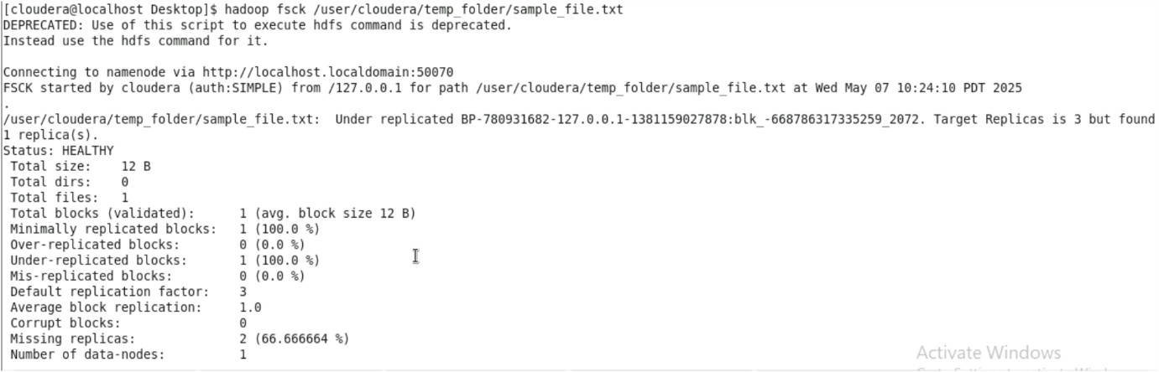
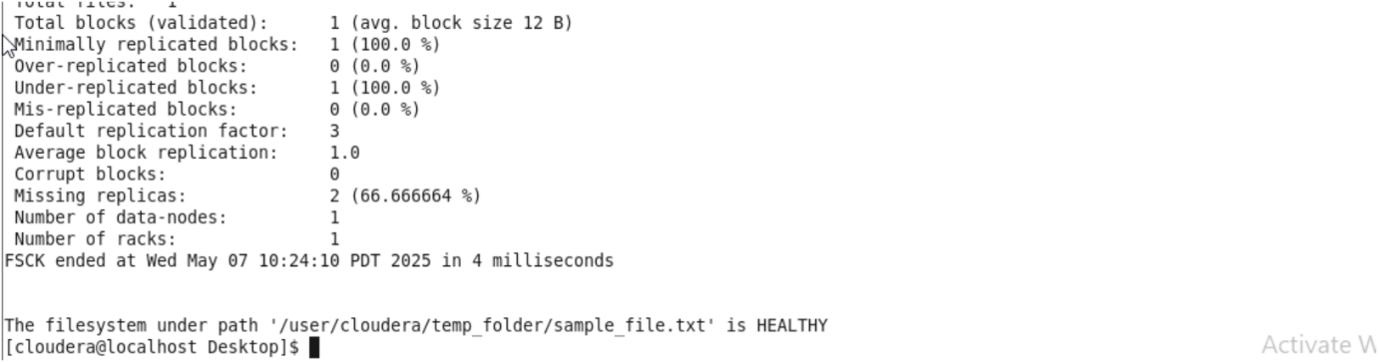
6. To change the replication factor
7. To remove file from a folder

